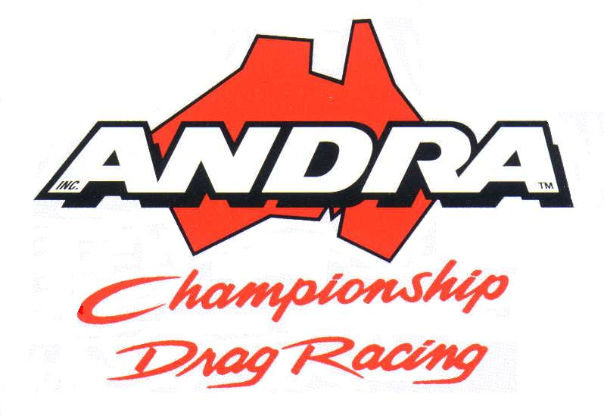 | 2007/2008 AUSTRALIAN TOP FUEL CHAMPIONSHIP – FINAL STANDINGS - 10/6/2008

 | Driver | State | Rd 1 | Rd 2 | Rd 3 | Rd 4 | Rd 5 | Rd 6 | Rd 7 | Final | TOTAL
1 | Phillip Read | NSW | 90 | 100 | 100 | 105 | 90 | 40 | 80 | 90 | 695
2 | Martin Stamatis | WA | 40 | 50 | 50 |  | 90 | 110 | 110 | 100 | 550
3 | Darren Morgan | VIC | 40 | 60 | 40 | 40 | 128 | 60 | 40 | 60 | 468
4 | Phil Lamattina | VIC | 40 | 40 |  | 65 | 158 | 20 | 40 | 40 | 403
5 | Allan Dobson | WA | 100 | 40 | 40 | 40 |  | 40 | 60 | 60 | 380
6 | Amanda Shepherd | NSW | 40 | 80 | 20 | 40 |  | 60 | 60 | 40 | 340
7 | Steve Read | QLD | 60 | 40 |  | 60 |  | 80 | 40 | 40 | 320
8 | Terry Sainty | NSW | 60 |  | 40 |  |  | 40 | 40 | 20 | 200
9 | Aaron Lynch | QLD |  |  |  | 80 |  |  |  | 40 | 120
10 | Mark Mariani | NSW | 20 |  | 60 |  |  | 20 |  |  | 100
11 | Mike Dunn | US |  |  | 80 |  |  |  |  |  | 80
12 | Roy Smith | QLD |  |  |  | 40 |  |  |  | 20 | 60
13 | Luke Shepherd | NSW |  |  |  |  |  | 40 | 20 |  | 60
14 | Cory McClenathan | US |  |  | 60 |  |  |  |  |  | 60
15 | Darren Di Filippo | VIC |  |  |  |  |  |  | 20 | 20 | 40

2007/2008 AUSTRALIAN TOP ALCOHOL CHAMPIONSHIP – FINAL STANDINGS - – 10/6/2008

 | Driver | State | Rd 1 | Rd 2 | Rd 3 | Rd 4 | Rd 5 | Rd 6 | Rd 7 | Final | TOTAL
1 | Brett Stevens | QLD | 40 | 70 | 158 | 105 | 65 | 110 | 45 | 105 | 698
2 | Aaron Lynch | QLD | 80 | 80 | 98 | 45 | 60 | 60 | 80 | 40 | 543
3 | Wayne Newby | NSW | 60 | 100 | 30 | 40 | 100 | 40 | 105 | 60 | 535
4 | Ben Bray | QLD | 50 | 40 | 90 | 80 | 40 | 40 | 60 | 40 | 440
5 | Steven Reed | QLD | 60 | 60 | 60 | 40 | 40 | 40 | 40 | 40 | 380
6 | Gary Phillips | QLD | 20 | 40 | 60 | 60 | 85 | 40 | 20 | 20 | 345
7 | Aaron Hambridge | NSW | 100 |  |  | 40 |  | 60 | 60 | 85 | 345
8 | John Cannuli | QLD | 40 | 40 |  | 60 | 40 | 80 | 40 | 20 | 320
9 | Debbie Reed | QLD | 40 | 20 | 30 | 40 |  |  | 40 | 20 | 190
10 | Damien Harris | WA |  | 40 | 60 |  |  |  |  |  | 100
11 | Dean Oakey | NSW |  | 20 |  | 20 |  |  |  | 60 | 100
12 | Aaron Deery | WA |  |  | 40 |  |  |  |  | 40 | 80
13 | Mark Sheehan | WA |  |  | 80 |  |  |  |  |  | 80
14 | Wayne Jones | QLD |  |  |  |  | 40 |  |  |  | 40
15 | Rick Gauci | NSW |  |  |  |  |  | 20 | 20 |  | 40
16 | Sam Fenech | NSW |  |  |  |  |  |  | 20 |  | 20
17 | Dean McLennan | QLD |  | 20 |  |  |  |  |  |  | 20
18 | Frank Intini | SA | 20 |  |  |  |  |  |  |  | 20

2007/2008 AUSTRALIAN TOP DOORSLAMMER CHAMPIONSHIP – FINAL STANDINGS - – 10/6/2008

 | Driver | State | Rd 1 | Rd 2 | Rd 3 | Rd 4 | Rd 5 | Rd 6 | Final | TOTAL
1 | John Zappia | WA | 105 | 80 | 158 | 85 | 90 | 65 | 60 | 642
2 | Brett Stevens | QLD | 40 | 20 | 90 | 60 | 165 | 40 | 85 | 500
3 | Ben Bray | QLD | 20 | 45 | 90 | 60 | 120 |  | 100 | 455
4 | Steve Stanic | NSW | 20 | 100 | 120 | 45 | 30 | 20 | 20 | 335
5 | Gary Phillips | QLD | 40 | 60 | 60 | 40 | 60 | 40 | 40 | 340
6 | Robin Judd | WA | 60 | 20 | 68 | 40 | 60 | 40 | 45 | 333
7 | Maurice Fabietti | NSW | 20 | 20 |  | 100 | 60 | 80 | 40 | 320
8 | Peter Kapiris | VIC | 20 | 45 | 60 | 20 | 90 | 20 | 20 | 275
9 | Victor Bray | QLD | 80 | 40 | 30 | 20 | 60 | 20 | 20 | 270
10 | Stuart Bishop | QLD | 65 | 60 | 60 |  |  | 65 | 20 | 270
11 | Aaron Lynch | QLD | 40 | 40 | 30 | 20 |  | 40 | 60 | 230
12 | Sean Mifsud | NSW | 20 |  |  | 20 |  | 100 | 40 | 180
13 | Steve Packman | QLD | 20 | 20 | 30 | 20 | 30 | 20 | 20 | 160
14 | Kath Stevens | QLD |  | 20 | 30 | 20 | 30 | 20 | 20 | 140
15 | Dino Brijeski | NSW | 40 |  |  | 40 |  |  |  | 80
16 | Gary Stevens | WA |  |  | 30 |  | 30 |  |  | 60
17 | Steve Dupond | NSW | 20 |  |  | 20 |  |  |  | 40
18 | Brett Gillespie | NSW | 20 |  |  | 20 |  |  |  | 40
19 | Ray Bernard | QLD |  |  |  |  |  | 20 | 20 | 40
20 | Andrew Sutton | NT |  |  |  |  |  | 20 | 20 | 40
21 | Peter Blake | NSW | 20 |  |  | 20 |  |  |  | 20
22 | Mark Belleri | NSW |  |  |  |  |  | 20 |  | 20
23 | Joe Cutelli | NSW | 20 |  |  | 20 |  |  |  | 20
24 | Joe Schembri | NSW | 20 |  |  |  |  |  |  | 20
25 | Peter Blake | NSW | 20 |  |  |  |  |  |  | 20
26 | Kim Petterwood | QLD |  | 20 |  |  |  |  |  | 20
27 | Russell Pavey | QLD |  |  |  |  |  |  | 20 | 20

2007/2008 AUSTRALIAN TOP BIKE CHAMPIONSHIP – FINAL STANDINGS - – 10/6/2008

 | Rider | State | Rd 1 | Rd 2 | Rd 3 | Rd 4 | Rd 5 | Rd 6 | Final | TOTAL
1 | Troy McLean | QLD | 80 | 85 | 158 | 60 | 150 | 60 | 60 | 653
2 | Athol Williams | NZ | 40 | 40 | 98 | 105 | 128 | 70 | 110 | 591
3 | Brett Stevens | QLD | 110 | 45 | 60 | 85 | 60 | 100 | 80 | 540
4 | Ian Ashelford | WA | 60 | 100 | 120 |  | 60 |  | 20 | 360
5 | Neville Smith | QLD |  | 60 | 60 | 40 | 60 | 40 | 40 | 300
6 | Mark Ashelford | WA |  |  | 90 |  | 90 |  | 60 | 240
7 | Rodney Salvestro | NSW | 40 | 40 |  | 40 |  | 40 | 40 | 200
8 | Leonard Azzopardi | NSW | 60 |  |  | 60 |  | 80 |  | 200
9 | Jay Upton | WA | 20 | 20 | 30 | 20 | 60 | 40 |  | 190
10 | Mark Drew | WA | 20 |  | 60 |  | 98 |  |  | 178
11 | Dennis Grant | SA | 20 | 60 |  | 40 |  |  | 40 | 160
12 | Craig Bonwick | NSW | 40 | 40 |  |  |  | 40 | 40 | 160
13 | Phillip Parker | VIC | 40 | 20 | 30 | 20 |  |  | 20 | 130
14 | Sam Parker | VIC |  |  |  | 40 |  | 20 | 20 | 80
15 | Sydney Standring | WA |  |  | 60 |  |  |  |  | 60
16 | Allan Herriman | QLD |  | 20 |  |  |  |  | 20 | 40
17 | Kim Stevens | WA |  |  | 30 |  |  |  |  | 30

2007/2008 AUSTRALIAN PRO STOCK CHAMPIONSHIP – FINAL STANDINGS - – 10/6/2008

 | Driver | State | Rd 1 | Rd 2 | Rd 3 | Rd 4 | Rd 5 | Final | TOTAL
1 | Aaron Tremayne | QLD | 105 | 110 | 40 | 100 | 105 | 60 | 520
2 | Tyronne Tremayne | QLD | 85 | 40 | 40 | 90 | 60 | 110 | 410
3 | John Barbagallo | QLD | 40 | 80 | 110 | 20 | 45 | 40 | 350
4 | Scott Porter | QLD | 40 | 60 | 80 | 60 | 60 | 40 | 340
5 | David Newcombe | QLD | 40 | 40 | 60 | 40 | 40 | 60 | 280
6 | Jason Grima | NSW | 60 | 60 | 60 | 20 | 20 | 20 | 240
7 | Lee Bektash | VIC |  |  |  | 40 | 80 | 80 | 200
8 | Bruce Leake | NSW | 60 |  |  | 40 | 40 | 20 | 160
9 | Frank Nirta | SA | 20 |  | 40 | 40 | 40 | 20 | 160
10 | Nick Xerakias | VIC |  |  | 40 | 60 |  |  | 100
11 | Rob Tucker | QLD |  | 40 |  |  | 20 | 40 | 100
12 | John Galea | QLD |  | 20 |  |  | 20 | 40 | 80
13 | Wayne Daley | QLD |  | 40 |  |  |  | 20 | 60
14 | Brian Pursell | QLD |  |  |  | 20 | 20 | 20 | 60
15 | Denis Whiting | QLD |  |  | 20 |  | 20 | 20 | 60
16 | Ian Brown | VIC | 40 |  |  | 20 |  |  | 60
17 | Richard Chilton | NSW |  |  |  |  | 20 | 20 | 40
18 | Joe Polito | NSW |  |  |  |  | 20 |  | 20
19 | Shane Tucker | QLD |  |  |  |  | 20 |  | 20
20 | Andrew Stavroulakis | NSW |  |  | 20 |  |  |  | 20

2007/2008 AUSTRALIAN PRO STOCK MOTORCYCLE CHAMPIONSHIP – FINAL STANDINGS - – 10/6/2008

 | Rider | State | Rd 1 | Rd 2 | Rd 3 | Rd 4 | Rd 5 | Final | TOTAL
1 | Peter Cochrane | QLD | 40 | 50 | 165 | 110 | 70 | 110 | 545
2 | Jason Lee | SA | 100 | 60 | 60 | 80 | 100 | 80 | 480
3 | Callam Godeassi | VIC | 50 | 100 | 120 | 40 | 60 | 40 | 410
4 | Michael Gilbertson | QLD | 40 | 40 | 60 | 40 | 80 | 60 | 320
5 | Maurice Allen | VIC | 60 | 40 | 90 |  | 40 |  | 230
6 | Graeme Weston | VIC | 80 | 80 | 60 |  |  |  | 220
7 | Alex Buxton | QLD |  |  |  | 60 |  | 40 | 100
8 | Lachlan Ireland | VIC |  |  |  | 40 | 40 | 20 | 100
9 | Edward Kepper | QLD |  |  |  | 60 | 40 |  | 100

